Media Contacts:
Sin Gogolak | SGogolak@pennhort.org| 215.988.1631
Lauren Scully | lscully@pennhort.org | 215.988.8884

FOR THEME ART ASSETS AND B-ROLL, CLICK HERE
FOR PHOTOS, CLICK HERE
Credit: Pennsylvania Horticultural Society

FOR IMMEDIATE RELEASE

Pennsylvania Horticultural Society Announces
2026 PHS Philadelphia Flower Show Theme
Rooted: Origins of American Gardening
February 28 – March 8, 2026 at the Pennsylvania Convention Center
Tickets on sale now at phsonline.org/the-flower-show/tickets.
PHILADELPHIA, PA – October 9, 2025 – Gardens aren’t just made; they’re passed down through generations, carried across oceans, lifetimes, and lands. Every seed carries a story – what's yours?
The 2026 PHS Philadelphia Flower Show celebrates the stories that ground us in gardening, whether it’s the nostalgia of a grandparent’s garden, a beloved family recipe that begins with the bright scent of freshly picked herbs and vegetables, or the heritage traditions that shape how we plant, grow, and gather. Through immersive garden exhibits and stunning floral displays, Rooted: Origins of American Gardening brings to life the personal stories, cultural traditions, and horticultural inspiration that connect us to plants, each other, and shape how we garden today.
As Philadelphia celebrates the 250th anniversary of American independence, the 2026 Flower Show offers a chance to reflect on the gardening legacies we’ve inherited and the ones we’re growing for the future, shaped by people and plants from around the world. This year’s Show will combine legacy and belonging with breathtaking artistry and larger-than-life creations that will take guests on a journey through a vivid world full of memory and magnificence.
The 2026 Flower Show marks the final chapter in a three-year trilogy of themes exploring the past, present, and future of gardening. In 2024, United by Flowers celebrated the current connections and community that grow through shared gardening experiences. In 2025, Gardens of Tomorrow sparked imaginations with visions of what the next generation of gardens could bring. Now, in 2026, Rooted: Origins of American Gardening looks to the past to honor the cultures, traditions, and stories that have planted the seeds of today’s gardens.
Together, these three themes tell a powerful story of the imagination, legacy, and cultural roots of gardening, setting the stage for the Pennsylvania Horticultural Society’s landmark 200th anniversary in 2027.
“This year’s Flower Show feels especially personal because every plant or garden carries a story behind it. We all have memories tied to plants and Rooted: Origins of American Gardening is about sharing those diverse experiences and the ways they connect us. It will be a show filled with memory, meaning, and incredible creativity,” said Seth Pearsoll, Vice President and Creative Director of the PHS Philadelphia Flower Show.
Now in its 197th year, the award-winning PHS Philadelphia Flower Show is a world-renowned gardening event and PHS’s main fundraiser for its acclaimed greening work throughout the Philadelphia region that aims to advance health and well-being for all.
“Rooted: Origins of American Gardening reflects PHS’s mission to use horticulture as a force for good by connecting people, places, and communities through the power of plants. As Philadelphia marks America’s 250th anniversary, this theme honors the deep roots of gardening history and culture that nourish our city and its neighborhoods. At PHS, we’re proud to carry forward this legacy by creating green spaces that foster resilience, equity, and well-being for all,” said PHS President Matt Rader.
Features to expect this year include:
- An immersive, show-stopping entrance garden that will blend historical influences with bold, modern design for a one-of-a-kind welcome.
- Explore America’s influence on gardening in a special exhibition celebrating the nation’s 250th anniversary, made possible by The America 250 Grant. This sweeping four-garden installation created by visionary designers from across the country, tells the evolving story of American gardening, honoring its roots, resilience, and reinvention.
- The world’s largest houseplant and indoor plant competition with thousands of entries from a community of hundreds of expert and amateur horticulturists. Participants blend science and artistry to compete for blue ribbons, with entries evaluated by expert judges from across the country and internationally. Open to all plant lovers, this competition offers a unique opportunity to showcase the deep roots of our shared plant heritage. Interested competitors can learn more HERE.
- Join leading gardening experts at the free Know to Grow speaker series, included with your admission. Learn directly from gardening’s leading voices as they share the wisdom, traditions, and techniques passed down through time, alongside fresh ideas that continue to grow our gardening story today.
- Enjoy perennial fan favorites, including botanical-themed crafting experiences and a marketplace of unique plants and handcrafted goods. Marvel at fluttering butterflies and master new skills in immersive, hands-on workshops, all celebrating the wonder of our connection to plants.
- Visit the Kids Cocoon for family fun, where little ones can dig into hands-on activities and daily programs designed to spark curiosity about the natural world, planting the seeds for a lifelong love of gardening.

2026 PHS Philadelphia Flower Show Ticket Prices
Tickets for the 2026 PHS Philadelphia Flower Show, Rooted: Origins of American Gardening, are on sale now!

There are two ways to experience the Flower Show:
- Become a PHS Member and enjoy exclusive perks like discounted tickets, early access on Members’ Preview Day, lounge access, and year-round savings.
- Purchase a single or multi-day ticket.

Either way, you’ll step into a spectacular celebration of gardens, creativity, and community while supporting PHS’s vital greening work.
Purchase individual tickets with one of the many ticketing options and experience the beauty and innovation of this world-class event. Ticket pricing will be divided into weekday, Friday/weekend, and after 4 pm pricing tiers, to offer guests greater flexibility.

The Floral Fanatic Pass returns this year, designed for true Flower Show enthusiasts who want to immerse themselves fully in the beauty and artistry of this beloved annual event! At a price of $100, the pass grants you unlimited daily entry to the Flower Show to explore every corner and experience the Flower Show's mid-week refresh featuring new exhibits in the artistic competitions and the PHS Hamilton Horticourt’s selection of best-in-class plants. Plus, you'll receive an exclusive Flower Show gift bag and enjoy premium seating at our daily Know to Grow lectures, ensuring a great view of all the action.

PHS is offering an Any-Day Flex Pass, the perfect gift for Flower Show lovers. For $60, this flexible ticket provides one-time admission on any single day of the Show, weekday or weekend. Purchase now and decide when you want to visit later. Perfect for gift giving!
Don't miss out on the Twilight Ticket, offering discounted evening admission starting at 4 pm for $33 on weekdays and $44 on the weekend. Perfect for the ultimate happy hour, surrounded by beautiful gardens and plants.
Ticket Pricing
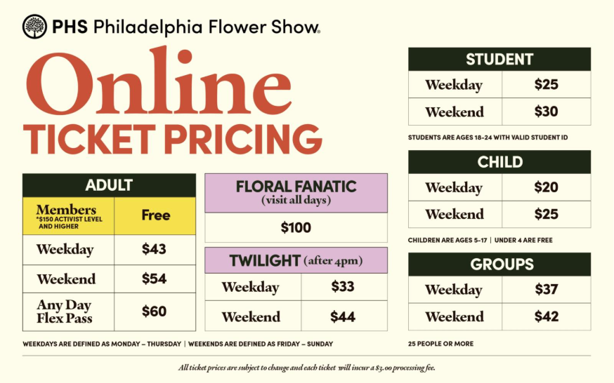
Notes:
- Weekdays are defined as Monday – Thursday; Weekends are defined as Friday – Sunday.
- Students are ages 18 – 24 with valid Student ID; Children are ages 5 – 17; Children under 4 are free.
- Each individual ticket will be subject to an additional $3.00 processing fee.

Group Discounts
Group discounts are available for groups of 25 or more. Group pricing is $37 per ticket on weekdays and $42 per ticket on weekends. Please email advtix@pennhort.org for more information.
PHS MEMBERSHIP BENEFITS
Become a PHS Member and experience the Flower Show like no one else. Enjoy the serenity and beauty of Member’s Preview Day on February 27, your chance to explore the Show early and linger among the gardens. Members also receive free or discounted tickets, savings at select shops, and special perks all year long. Best of all, your membership supports the vital work of PHS in communities across the region. To become a member, visit PHSonline.org/support-phs/membership.
- 10% discount on two or more Flower Show tickets (by member level and valid for preview and public hours) or join as an Activist or higher member for complimentary member Flower Show tickets!
- Special edition Flower Show gift
- Access to Members’ Preview Day and Members-only preview hours
- Access to the Flower Show Members’ Lounge to relax and rejuvenate
- Hear from famed garden speakers at exclusive Members-only Know to Grow sessions
- Discounts at participating Flower Show Marketplace vendors

ABOUT THE PHS PHILADELPHIA FLOWER SHOW
The award-winning PHS Philadelphia Flower Show is the nation's largest, and the world’s longest-running horticultural event and features stunning displays by some of the world’s premier floral and landscape designers. Started in 1829 by the Pennsylvania Horticultural Society, the Show introduces diverse and sustainable plant varieties and garden and design concepts. In addition to acres of garden displays, the Flower Show hosts world-renowned competitions in horticulture and artistic floral arranging, gardening presentations and demonstrations, and special events.
ABOUT THE PENNSYLVANIA HORTICULTURAL SOCIETY
The Pennsylvania Horticultural Society (PHS), an internationally recognized nonprofit organization founded in 1827, uses horticulture to advance the health and well-being of the Greater Philadelphia region. PHS programs create healthier living environments, increase access to fresh food, expand access to jobs and economic opportunities, and strengthen deeper social connections between people. PHS’s work spans 250 neighborhoods; an expansive network of public gardens and landscapes; year-round learning experiences; and the nation’s signature gardening event, the Philadelphia Flower Show. PHS provides everyone with opportunities to garden for the greater good as a participant, member, donor, or volunteer.
###

